**COVER PAGE (WILL BE REPLACED)**

# Business Understanding

Purpose of the Dataset

Describe the purpose of the data set you selected (i.e., why was this data collected in the first place?).

Define and Measure the Outcomes

Describe how you would define and measure the outcomes from the dataset. That is, why is this data important and how do you know if you have mined useful knowledge from the dataset?

Effectiveness of a Prediction Algorithm

How would you measure the effectiveness of a good prediction algorithm? Be specific.

We are looking at customer data from a north American Telco provider. The purpose of the data set is to retain existing customers. In telecommunications, the estimated cost of new customer acquisition is approximately 5x higher than retaining an existing customer. Furthermore, only a third of customers switch carriers due to lower prices; more and more factors such as dissatisfaction with quality of service, advancing technology and media features, competitors having better cellular coverage, and poorly implemented loyalty programs are all contributing to customer attrition. By analyzing all relevant customer data, we will effectively

predict behavior to retain customers.

<https://www.entrepreneur.com/article/225415>

<https://www.demandjump.com/blog/customer-acquisition-cost-by-industry>

<https://www.performancemagazine.org/june-smartkpi-telecom-sub-acquisition/>

<https://www.invespcro.com/blog/customer-acquisition-retention/>

<https://www.annexcloud.com/blog/21-surprising-customer-retention-statistics-2018/>

# Data Understanding

Data Description

Describe the meaning and type of data (scale, values, etc.) for each

attribute in the data file.

A description of the “Telco Churn Data Set” from Kaggle can be found on the website: <https://www.kaggle.com/blastchar/telco-customer-churn>.

It is a random sampling of approximately 7000 anonymized customers from an unnamed Telco provider. It contains 20 features that describe such characteristics as their demographics, their account information, and their subscribed services.

Data Dictionary  
We are provided a CSV set of 21 features and 7043 anonymized customers.

* **customerID**: Unique alpha-numeric string to anonymously represent an individual customer
* **gender**: Categorical String value to represent customer's gender (Male or Female)
* **SeniorCitizen**: Boolean int value to show whether the customer is a senior citizen or not (1, 0)
* **Partner**: Boolean string value showing whether the customer has a partner or not (Yes, No)
* **Dependents**: Boolean string value showing whether the customer has dependents or not (Yes, No)
* **tenure**: Numeric value showing number of months the customer has stayed with the company
* **PhoneService**: Boolean string value showing whether the customer has a phone service or not (Yes, No)
* **MultipleLines**: Categorical string value that shows if the customer has multiple lines or not (Yes, No, No phone service)
* **InternetService**: Categorical string value that shows the customer’s internet service provider (DSL, Fiber optic, No)
* **OnlineSecurity**: Categorical string value showing whether the customer has online security or not (Yes, No, No internet service)
* **OnlineBackup**: Categorical string showing whether the customer has online backup or not (Yes, No, No internet service)
* **DeviceProtection**: Categorical string showing whether the customer has device protection or not (Yes, No, No internet service)
* **TechSupport**: Categorical string showing whether the customer has tech support or not (Yes, No, No internet service)
* **StreamingTV**: Categorical string showing whether the customer has streaming TV or not (Yes, No, No internet service)
* **StreamingMovies**: Categorical string showing whether the customer has streaming movies or not (Yes, No, No internet service)
* **Contract**: Categorical string that represents the contract term (Month-to-month, One year, Two year)
* **PaperlessBilling**: Boolean string showing whether the customer has paperless billing or not (Yes, No)
* **PaymentMethod**: Categorical string that shows the customer’s payment method (Electronic check, Mailed check, Bank transfer (automatic), Credit card (automatic))
* **MonthlyCharges**: Numeric value showing the amount charged to the customer each month
* **TotalCharges**: Numeric value showing the total amount charged to the customer
* **Churn**: Boolean string showing whether or not the customer 'churned' or terminated services (Yes or No)

Data Quality

Explain any missing values, duplicate data, and outliers.

Are those mistakes? How do you deal with these problems? Be specific.

For the most part this data is production ready. Two modifications were necessary.

First, the **MonthlyCharges** has 11 missing values. [**Code Appendix 1A]** Because it is such a small percentage of the total 7000+ values it should not prove to be problematic. For the moment we are simply excluding these 11 observations from the initial data exploration and visualization exercises.

Second, the **SeniorCitizen** variable is given as numeric, when for all practical purposes it is a categorical factor. I.e. a customer cannot be 0.77 of a senior citizen; they either are under 65 or they are not. For this we simply converted from an integer to a categorical factor. [**Code Appendix 1B**]

NUMERIC

BoxPlot of Monthly Charges for each Churn Category

shows a significant difference in the distribution. **If we validated this w/ a 2-sample t-test it will likely show the 2 distributions differ significantly**. This is an observation so we can NOT make a reference to causality, BUT because its random we CAN make generalizations. Thus there is some correlation between Monthly Charges and Churn, which the Logistic Regression and / or LDA will illuminate

**Figure 1: Boxplot of Monthly Charge for each Churn Category**

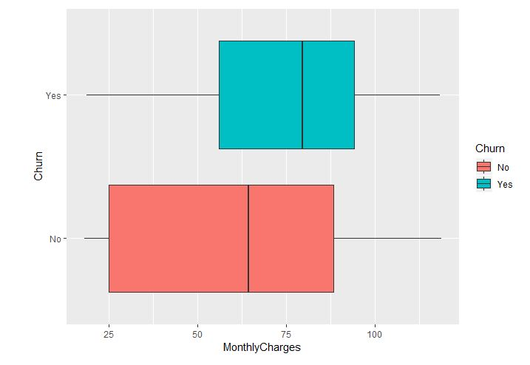

BoxPlot of Tenure for each Churn Category

As per above, a **Welch’s 2 sample t-test** would likely show significant deviations in the two different distributions. This is fairly intuitive; customers who churn usually do so within the first 1 – 2 years of the service contract.

**Figure 2: Boxplot of Tenure for each Churn Category**

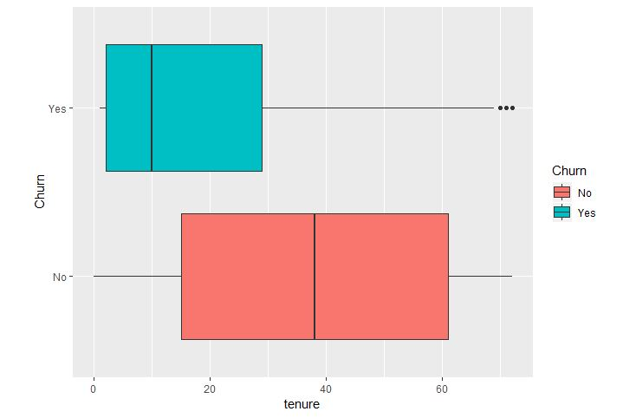

Simple Statistics

Give simple, appropriate statistics (range, mode, mean, median, variance,

counts, etc.) for the most important attributes and describe what they mean or if you found something interesting. Note: You can also use data from other sources for comparison. Explain the significance of the statistics run and why they are meaningful.

Summary Statistics of Tenure

Min. 1st Qu. Median Mean 3rd Qu. Max.

0.00 9.00 29.00 32.37 55.00 72.00

Summary Statistics of Monthly Charges

Min. 1st Qu. Median Mean 3rd Qu. Max.

18.25 35.50 70.35 64.76 89.85 118.75

Summary Statistics of Total Charges

Min. 1st Qu. Median Mean 3rd Qu. Max. NA's

18.8 401.4 1397.5 2283.3 3794.7 8684.8 11

The total charges is skewed to the right as shown in the summary statics meaning there is an abundant amount of extreme total charges in the data. You can see the average is around $2000. Fifty percent of the data ranges from approximately $400-$4,000.

The tenure is slightly skewed to the right as shown in the summary statistics. You can see the average is around 32. Fifty percent of the data ranges from approximately 9-55.

The monthly charges show that the median is greater than the mean.

Visualization

Visualize the most important attributes appropriately (at least 5 attributes). Important: Provide an interpretation for each chart. Explain for each attribute why the chosen visualization is appropriate.

The five important variables are: contract, payment methods, multiple lines, tech support, and total charges. You can view these below and their reasonings.

**CONTRACT: MONTHLY**

Notice the RATIO of Churn Yes vs No is disproportionate, having almost a 1 to 1. Compared to 1 year and 2 year that more closely align to the total Yes vs No behavior. It is also important to note here that most of them pay with an eCheck.

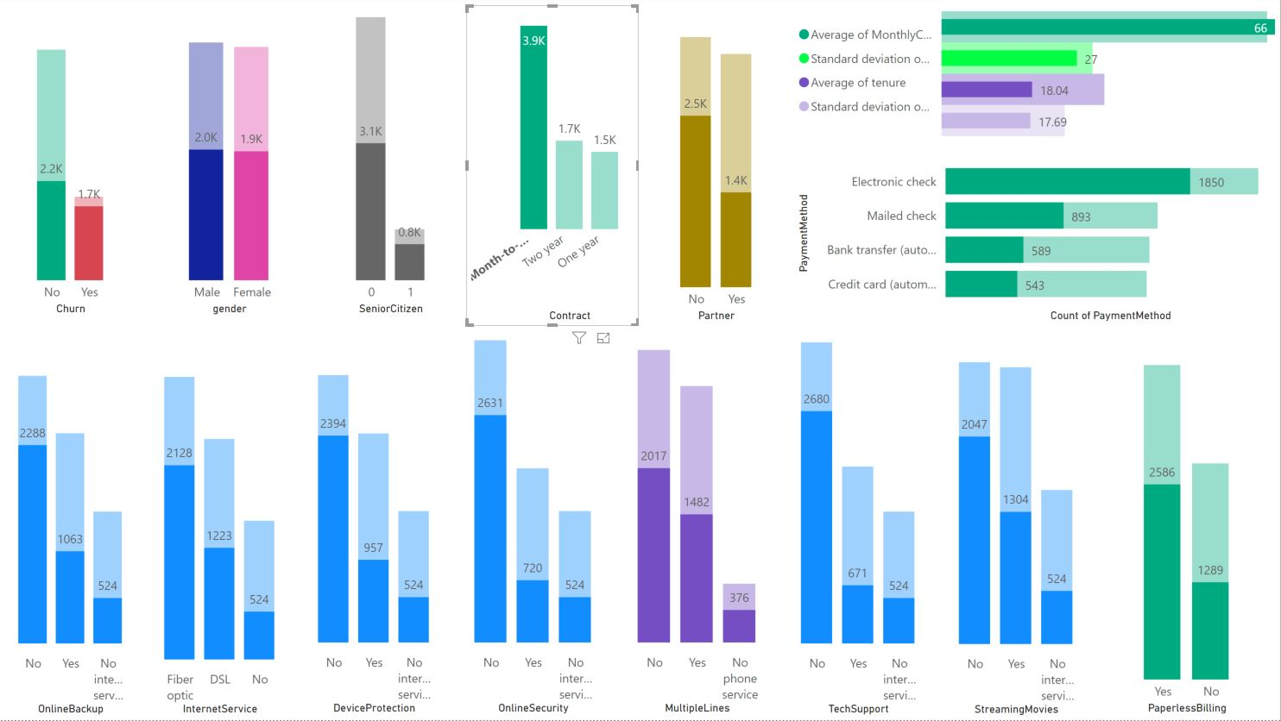

**Payment Method**

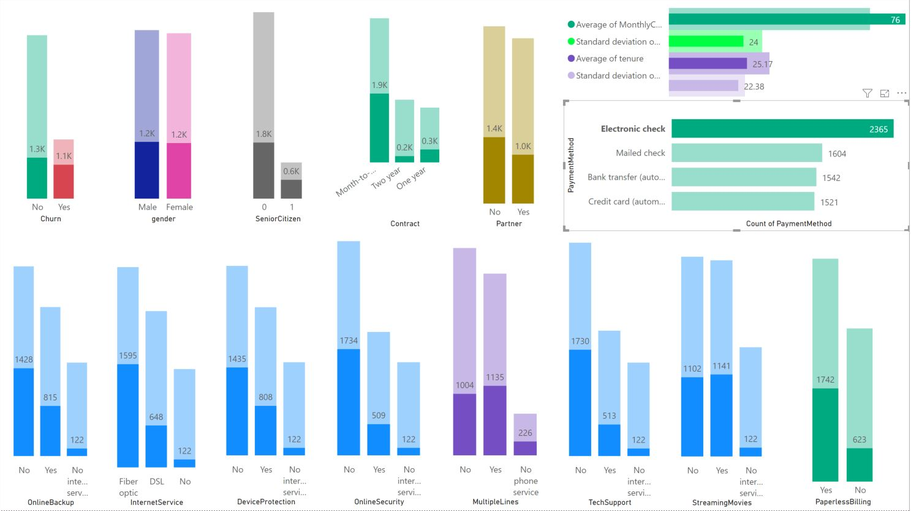

Most customers prefer to significantly use an electronic check.

**Multiple Lines**

PHONE SERVICE: MULTI LINE

Of the 2967 customers who have multiple phone lines, 340 of them have no Internet. Possible opportunity to market services like Skype or WebEx; advanced VoIP services and video conferencing. Notice, that they have higher Avg Monthly Spend and higher Avg Tenure. However, also notice the ratio for Churn [~ 2 to 1] is slightly higher vs the entire data set’s Churn ratio [~ 3 to 1]. Perhaps maybe they spend their money more “productively” getting modern features like VoIP and Video Conferencing for the same money, and now multiple lines aren’t needed. It could also be better loyalty, better service, and people could have migrated off of old technology like analog phone lines.

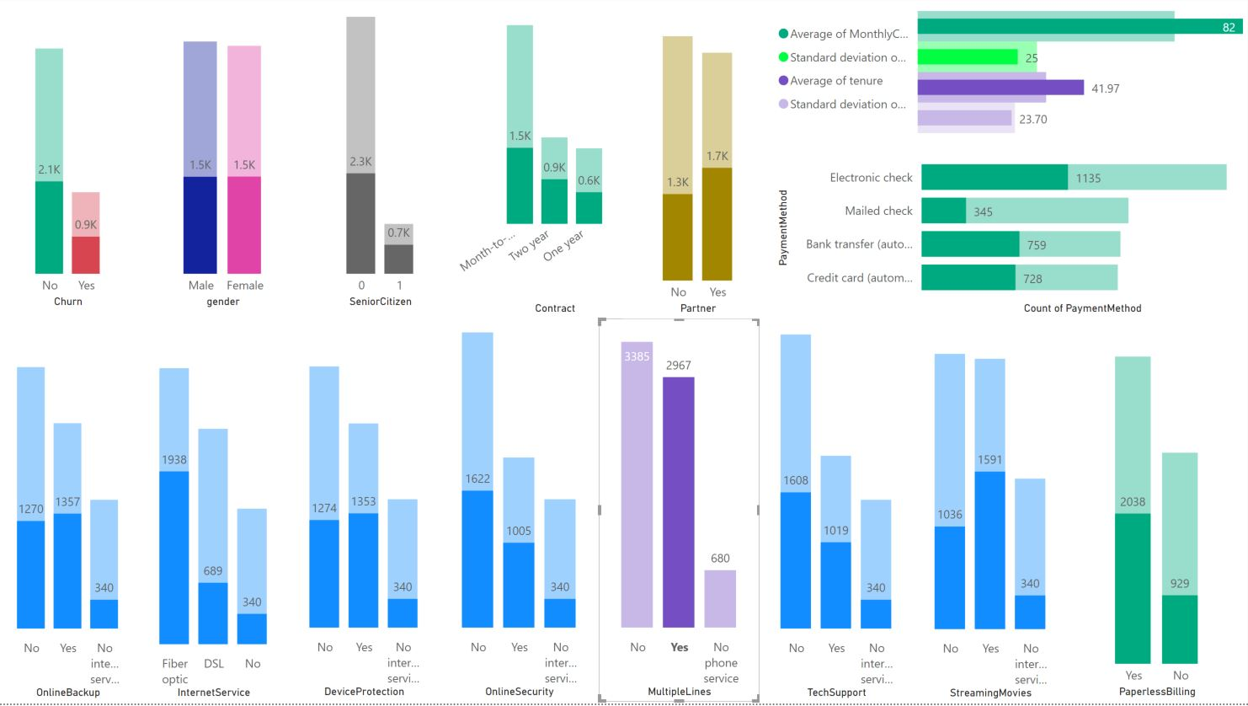

**Tech Support**

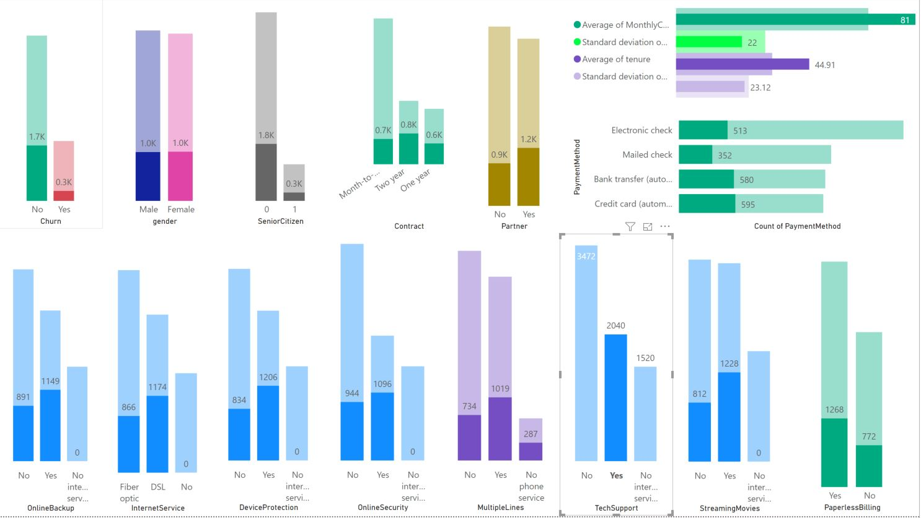

People with tech support tend to have a higher rate of staying with the company.

**Total Charges**

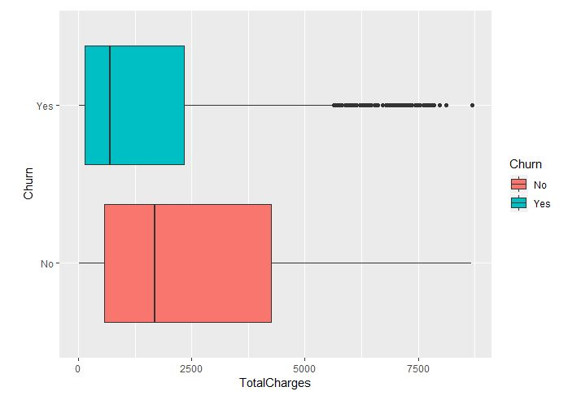

If a customer’s total charges are lower they are more likely to leave the company. It is also interesting to note that the range of total charges is smaller with those who leave the company.

One-year and two-year contracts account for higher percentages for customers who stayed.

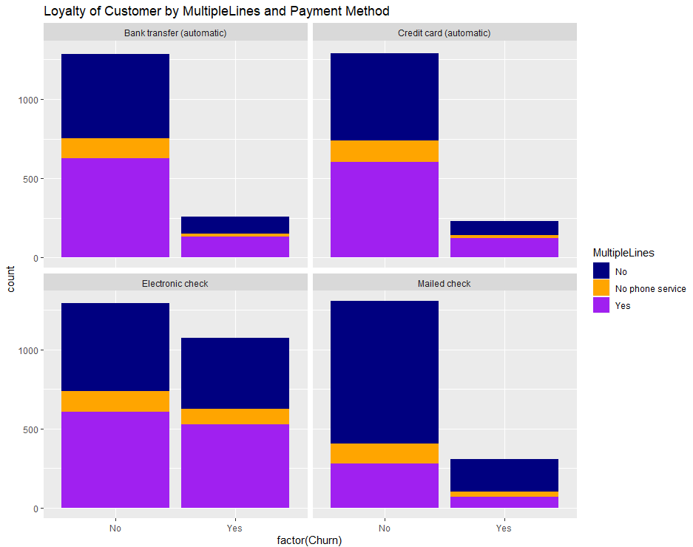

People without multiple lines and use mailed check have higher probability to stay.

Meanwhile, people with electronic check has higher probability to leave.

People who have tech support and no internet service are more likely to stay with the company.

Explore Relationships

Explore relationships between attributes: Look at the attributes via scatter plots, correlation, cross-tabulation, group-wise averages, etc. as appropriate. Explain any interesting relationships.

Interesting Trends

Tenure and total charges have positive relationship but this correlation varies by different types of contracts. Holding the total charges between 0 and $5000, the tenure is longer for two-year contract than a one-year or month-to-month contract. When total charges are more than $5000 or $7500, this direction can be reversed.

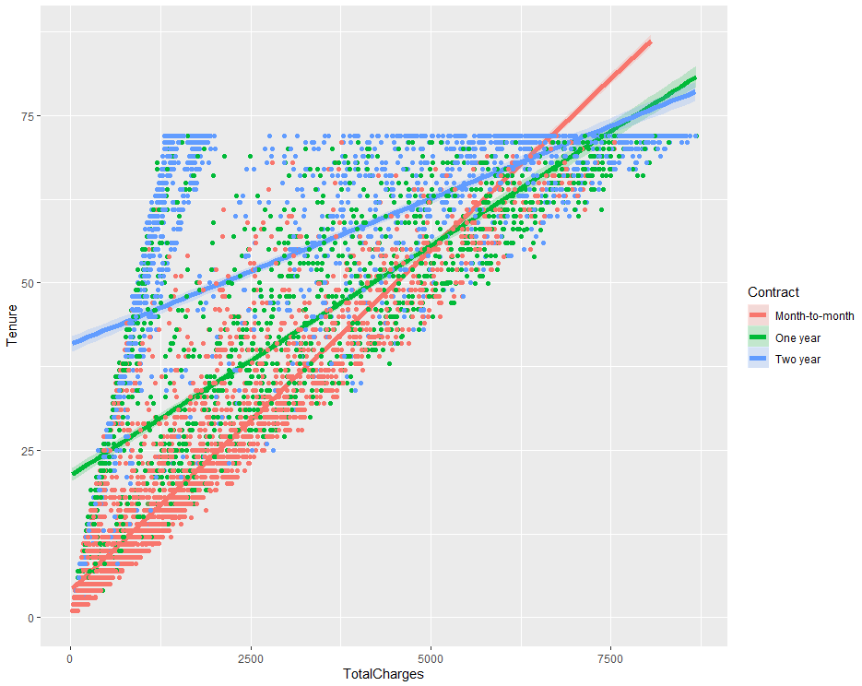

Matrix Scatter Plot



Month-to-month contract has the highest percentages of customers who left.

Two-year contract has the highest percentages of customers who stay.

> table(tele$Churn, tele$Contract)

Month-to-month One year Two year

No 2220 1307 1647

Yes 1655 166 48

DSL internet service has higher percentages of customers who stay than optic internet service. People with no internet service stay longer than people with internet service.

> table(tele$Churn, tele$InternetService)

DSL Fiber optic No

No 1962 1799 1413

Yes 459 1297 113

Interesting Relationship

Identify and explain interesting relationships between features and the class you are trying to predict (i.e., relationships with variables and the target classification).

The dependent variable is whether a customer stays or leave which is indicated by the variable churn. There were many interesting relationships between factors and class. For example, one-year and two-year contracts account for higher percentages for customers who stayed. Also, People without multiple lines and use mailed check have higher probability to stay. Meanwhile, people with electronic check has higher probability to leave. People who have tech support and no internet service are more likely to stay with the company.

The total charges and total charges have an interesting relationship. If they pay more, they will be a more loyal customer and stay longer. If the tenure is longer, the churn rate is lower.

Other Features

Are there other features that could be added to the data or created from existing features? Which ones?

# Appendix